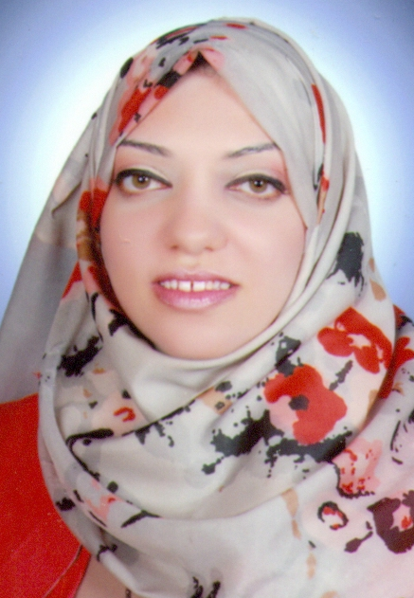
C.V

Full Name: Dina Kamal Morad Ibrahim
Present Address: 92 Saad Zaghlol St
City: Assiut Country: Egypt
Tele. Res: 2-088-2348843 Mobile# +20 – 100- 5311689
E-Mail: Dina-morad@Outlook.com

PERSONAL INFO:
Date Of Birth: 30 Dec, 1988 Gender: Female
Present Nationality: Egyptian Marital Status: Single

EDUCATION:
Bachelor Degree in Political science from faculty of Commerce - Assiut University
Year of graduation: 2012 – 2013 GPA: Very good

Career History:

From Date To Date Company Position
Nov – 2013 Till Now Assiut University Demonstrator

LANGUAGES:
Language Ability

- ARABIC Read, Write & Speak (Native Language)
- ENGLISH Read, Write & Speak

